**Ideation Phase**

**Blood Cell Classification Project**

| Date | 20 Feb 2025 |
| --- | --- |
| Team ID | LTVIP2026TMIDS86637 |
| Project Name | hematovision: advanced blood cell classification using transfer learning |
| Maximum Marks | 4 Marks |

# **1. Ideation Phase**

## **1.1 Introduction**

The Ideation Phase marks the foundational stage of the project lifecycle, where ideas are explored, problems are identified, and feasible solutions are conceptualized. This phase focuses on understanding real-world challenges, brainstorming innovative solutions, and selecting the most suitable idea for further development. The outcome of this phase forms the base for requirement analysis, design, planning, and implementation.This project is centered on the application of Artificial Intelligence (AI) and Deep Learning techniques to automate the classification of blood cells from microscopic images, aiming to assist healthcare professionals in faster and more accurate diagnosis.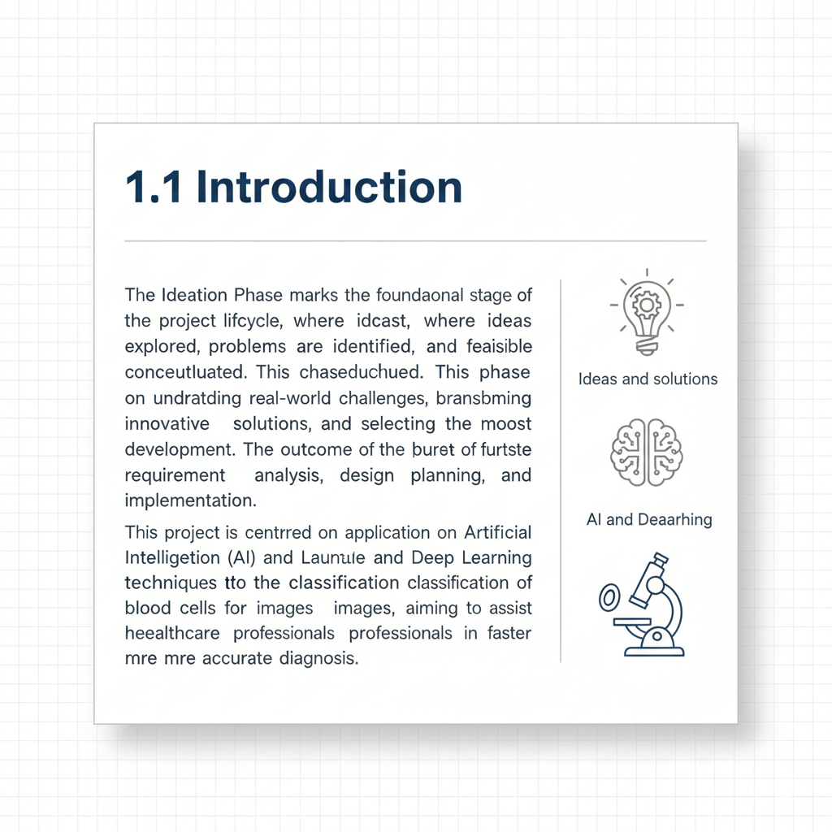

**1.2 Problem Identification**

Manual examination of blood smear images by pathologists is a time-consuming and error-prone process. The increasing volume of patients, shortage of skilled professionals, and subjective interpretation of results can lead to delayed diagnosis and inconsistencies. Early and accurate identification of blood cell types is critical for detecting diseases such as anemia, leukemia, and infections.

Key problems identified: - High dependency on manual analysis - Possibility of human error and fatigue - Time-consuming diagnostic procedures - Limited access to expert pathologists in remote areas



## **1.3 Motivation**

Advancements in machine learning and computer vision provide an opportunity to automate medical image analysis. Automating blood cell classification can significantly reduce diagnosis time, improve accuracy, and support medical professionals in decision-making. The motivation

behind this project is to leverage AI for social good by contributing to improved healthcare outcomes.

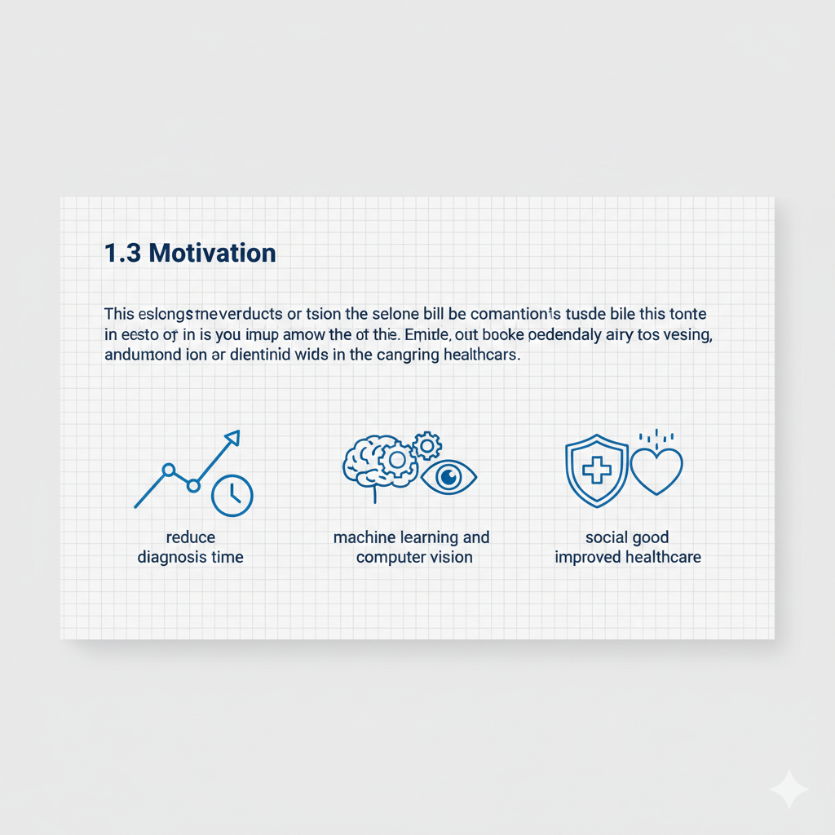

## **1.4 Brainstorming of Ideas**

During the ideation phase, multiple ideas were brainstormed and evaluated based on feasibility, impact, and technical complexity:

1. Automated Blood Cell Classification using Deep Learning

2. Disease Prediction System based on Blood Test Reports

3. Medical Chatbot for Preliminary Diagnosis

4. Smart Health Monitoring System using IoT

5. Image-Based Tumor Detection System

After comparative analysis, Automated Blood Cell Classification was shortlisted due to availability of datasets, clear problem definition, high medical relevance, and strong alignment with AI and image processing concepts.

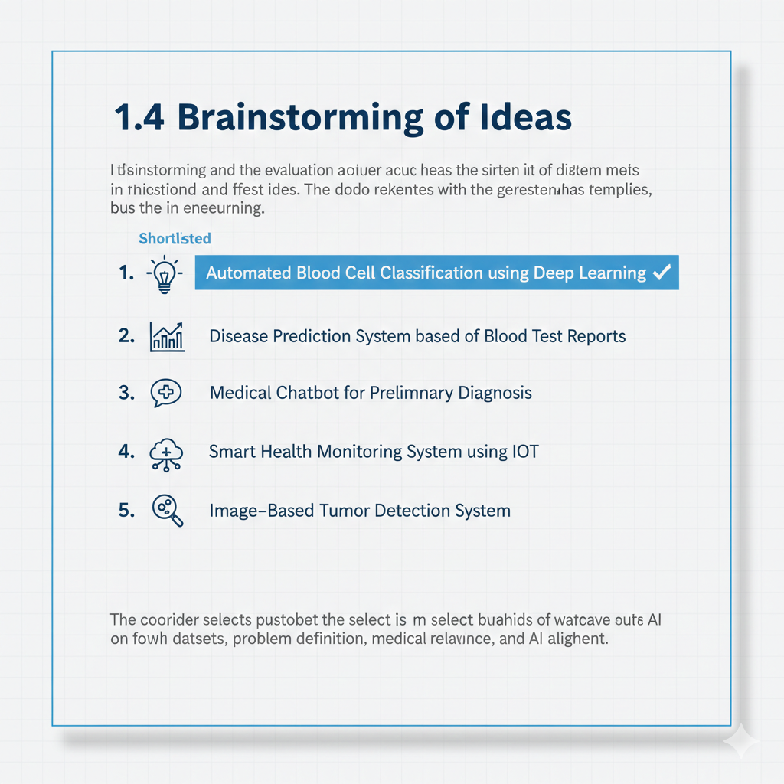

## **1.5 Proposed Solution**

The proposed solution is an AI-powered system that classifies blood cells (such as RBCs, WBCs, Platelets, etc.) from microscopic images using Convolutional Neural Networks (CNNs). The system takes blood smear images as input and outputs the predicted blood cell category with high accuracy.

High-level solution approach: - Input microscopic blood cell images - Preprocessing and augmentation of images - Feature extraction using deep learning models - Classification of blood cells into predefined categories - Display of results for analysis and decision support

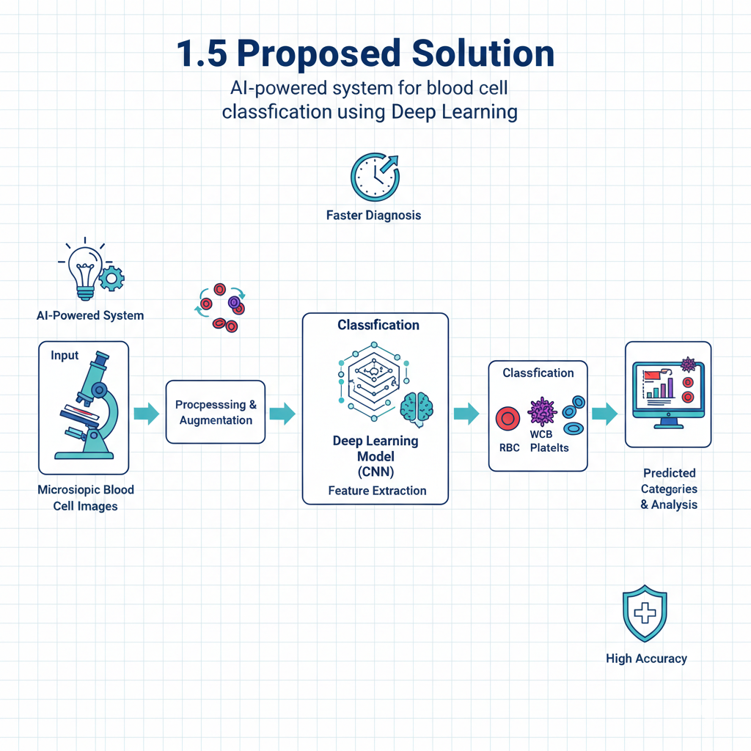

## 

## **1.6 Objectives of the Project**

The main objectives identified during ideation are: - To develop an automated system for blood cell classification - To reduce dependency on manual microscopic analysis - To improve accuracy and efficiency in medical diagnosis - To apply deep learning techniques in the healthcare domain - To build a scalable and reusable AI-based solution

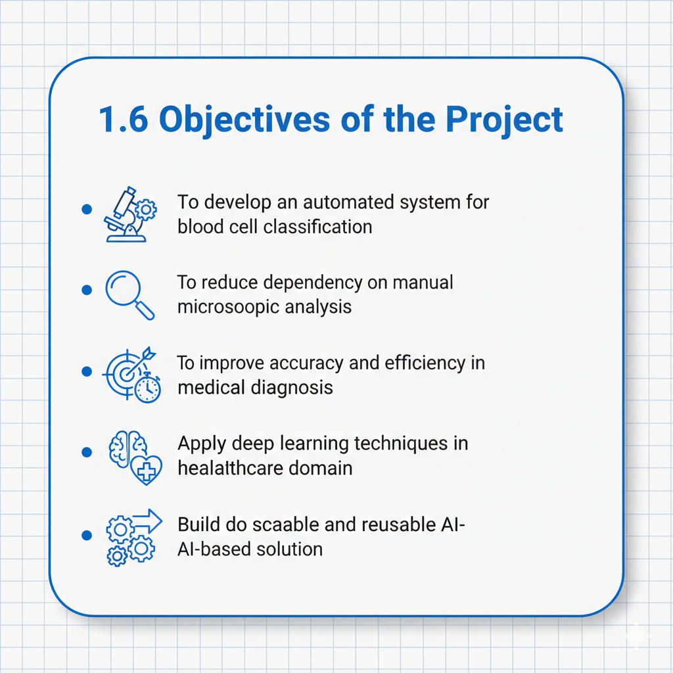

## **1.7 Feasibility Analysis**

### **Technical Feasibility**

· Availability of labeled blood cell image datasets

· Use of established deep learning frameworks such as TensorFlow/Keras

· Feasibility of training CNN-based models on standard hardware

### **Operational Feasibility**

· Can be integrated as a decision-support tool for medical professionals

· Simple user interaction through a software interface

### **Economic Feasibility**

· Uses open-source tools and datasets

· No significant additional hardware cost required

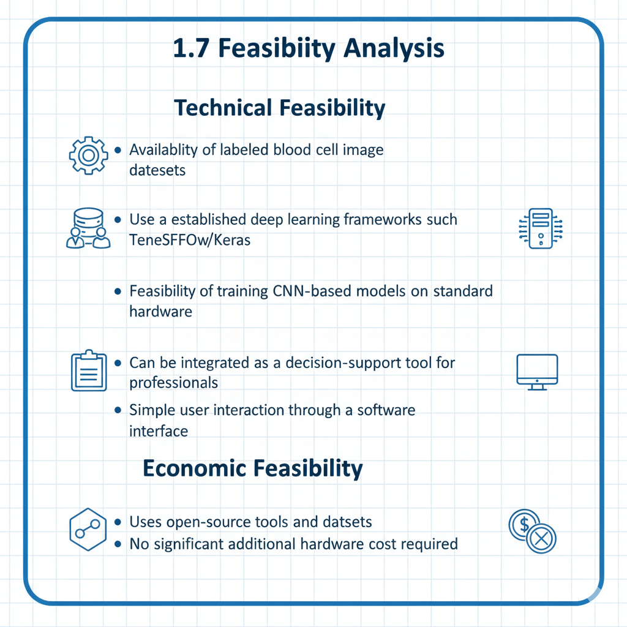

## **1.8 Stakeholders**

· Pathologists and medical professionals

· Hospitals and diagnostic laboratories

· Patients

· Researchers in medical AI

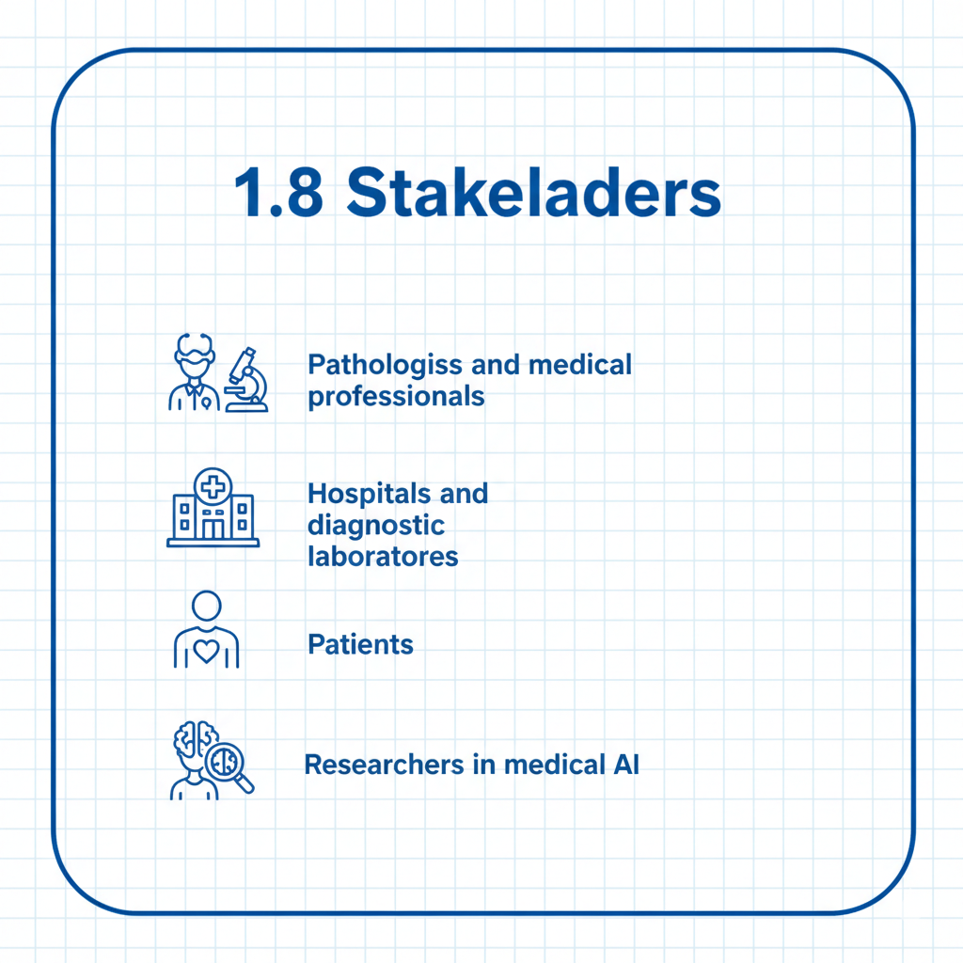

## **1.9 Constraints and Assumptions**

### **Constraints**

· Limited dataset size and image quality

· Computational limitations during training

· Model performance dependent on data diversity

### **Assumptions**

· Input images are properly captured and labeled

· System is used as an assistive tool, not a replacement for doctors

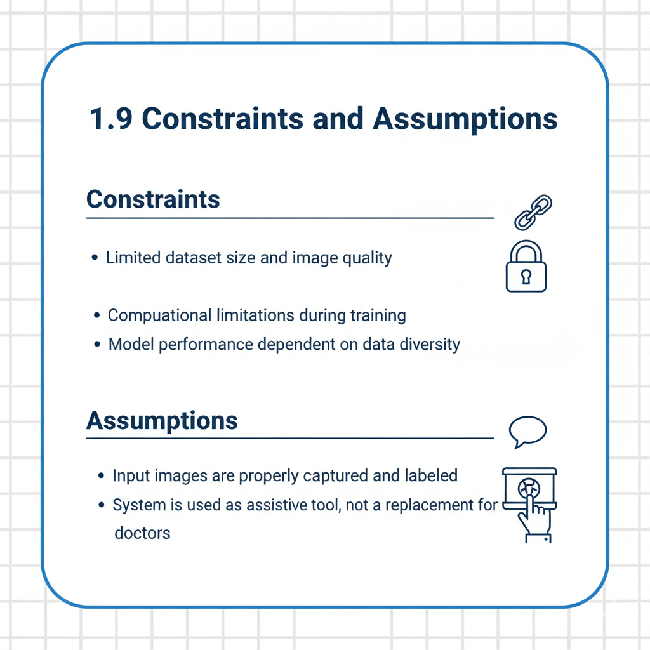

## **1.10 Conclusion**

The Ideation Phase successfully identified a critical healthcare problem and proposed a feasible AI-based solution for automated blood cell classification. The selected idea demonstrates strong technical viability, societal impact, and academic relevance. This phase lays a solid foundation for progressing into requirement analysis, system design, and development phases